**13. ReactJS-HOL**

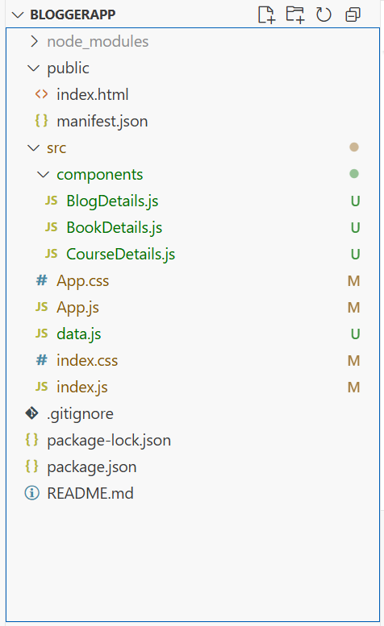

**CourseDetails.java**  
import React from "react";

function CourseDetails({ courses, showCourses }) {

  // Conditional rendering using logical &&

  return (

    <div className="card">

      <h2>Course Details</h2>

      {showCourses &&

        courses.map((course) => (

          <div key={course.id}>

            <h3>{course.cname}</h3>

            <p>{course.date}</p>

          </div>

        ))}

    </div>

  );

}

export default CourseDetails;

**BlogDetails.java**  
import React from "react";

function BlogDetails({ blogs, showBlogs }) {

  if (!showBlogs) {

    return (

      <div className="card">

        <h2>Blog Details</h2>

        <p>No blogs available</p>

      </div>

    );

  }

  return (

    <div className="card">

      <h2>Blog Details</h2>

      {blogs.map((blog) => (

        <div key={blog.id}>

          <h3>{blog.title}</h3>

          <p><strong>{blog.author}</strong></p>

          <p>{blog.content}</p>

        </div>

      ))}

    </div>

  );

}

export default BlogDetails;

**BookDetails.java**  
import React from "react";

function BookDetails({ books, showBooks })

{

  return (

    <div className="card">

      <h2>Book Details</h2>

      {showBooks ? (

        books.map((book) => (

          <div key={book.id}>

            <h3>{book.bname}</h3>

            <h4>{book.price}</h4>

          </div>

        ))

      ) : (

        <p>No books to display</p>

      )}

    </div>

  );

}

export default BookDetails;

**App.js**  
  
import React, { useState } from "react";

import "./App.css";

import { books, blogs, courses } from "./data";

import BookDetails from "./components/BookDetails";

import BlogDetails from "./components/BlogDetails";

import CourseDetails from "./components/CourseDetails";

function App() {

  const [showBooks, setShowBooks] = useState(true);

  const [showBlogs, setShowBlogs] = useState(true);

  const [showCourses, setShowCourses] = useState(true);

  return (

    <div className="container">

      <CourseDetails courses={courses} showCourses={showCourses} />

      <BookDetails books={books} showBooks={showBooks} />

      <BlogDetails blogs={blogs} showBlogs={showBlogs} />

    </div>

  );

}

export default App;

